**Opening images for image analysis through MoBIE**

Open Fiji 🡪 Plug-ins 🡪 MoBIE 🡪 Open 🡪 Open table

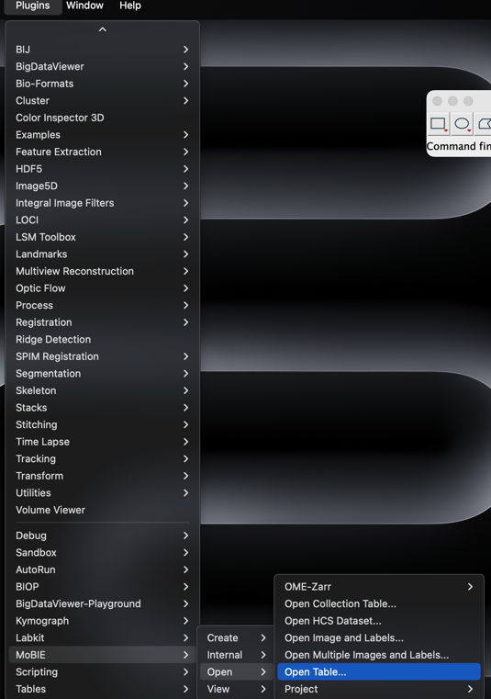

Table path: The path to the summary.txt file. E.g. for stage 8 images: (mb://furlong.embl.de/furlong/project/97_synthetic_locus/Image_analysis/stage_8_image_analysis/20240624-stage8/summary_.txt)

Note that I have the stage 8 and stage 9 embryos in different files.

Image path columns: FileName_Result.Image_IMG

Images & Labels Root folder: The path to the whole folder containing all the images. E.g. for stage 8 images: (mb://furlong.embl.de/furlong/project/97_synthetic_locus/Image_analysis/stage_8_image_analysis/20240624-stage8)

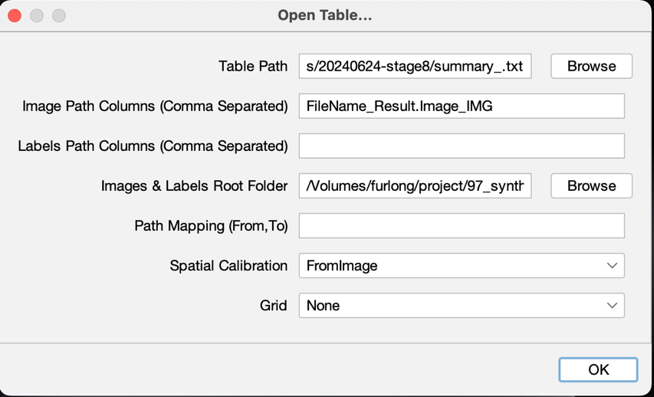

Lastly it gives me this viwer:

